**Alice plays with graph**

You have to complete **T tasks** today.  
In each task, Alice and Bob are playing with a Airline network of **N airports**.  
At the start of the game, they are **no airlines** connecting any two airports. Bob will then make **M turns**.  
Each of next **M turns**-  
**Bob selects two airports u and v and adds a two way airline between these cities. Alice now takes ownership of one these airports and assigns other to the Bob. Previous connections stay as it is with the next turn too.**  
In some turns, Alice realises that is impossible to assign airports to her and Bob.  
Since, Bob has made many turns so Alice has come to you asking for the maximum number of turns from the start of the game till which such assignment is possible.  
Formally, for each task you have to tell **maximum E such that for the Airline network that is formed after adding connections of 1,2,...,E turns, it is possible to assign the airports such that Alice owned airports are connected only to Bob owned airports and vice versa.**

**Input Format**

First line contains the number of tasks **T**.  
Second line of each task contains the number of airports **N** and the number of turns that bob makes **M**  
Then, follows M lines -  
Each of the M lines has two integers u and v describing the airline connection that bob adds is between u and v.

**Constraints**

1 <= T <= 5  
2 <= N, M <= 1e5  
1 <= u, v <= N  
There are no edges at the start of the game. The graph is a undirected graph.

**Output Format**

Output T lines.  
Each line has a single integer E, the answer of each task.

**Sample Input 0**

2

4 3

1 2

2 3

3 4

4 5

1 2

1 4

4 3

1 3

2 3

**Sample Output 0**

3

3

**Explanation 0**

In second task,  
There are 4 airports.  
In the bracket assignment of aiports is shown, **A refers to Alice and B for Bob**.  
After the first turn,  
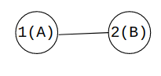  
After the second turn,  
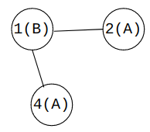  
**Note: Ownership of airports can be changed after each turn**  
After the third turn  
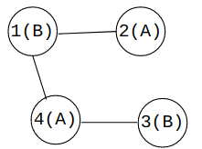  
After the Fourth turn  
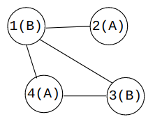  
After the fourth turn, it is not possible to assign, it will always result in two airports of same ownership getting connected.  
After the Fifth turn  
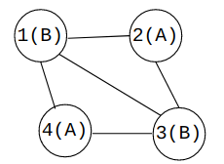  
After the Fifth turn, it is not possible to assign, it will always result in two airports of same ownership getting connected.  
**Thus, upto 3 turns at maximum, it was possible to do the present task**